**Practical 02**

**Aim: Write a program to Python program to demonstrate use of regular expression for suitable application.**

**Regular Expression:**

* A regular expression is a special sequence of characters that helps you match or find other strings or sets of strings, using a specialized syntax held in a pattern.
* Regular Expression was derived in 1951 by a famous mathematician, Stephen Cole Kleene.
* He described regular expression using regular sets.
* Regular expressions are also referred to as regex patterns, REs and regexes.
* The main purpose of using Regular Expression are as follows:

1. Validation
2. Searching
3. Searching and Replacing
4. Splitting

* You can perform various operations with the help of regular expression such as Boolean, Grouping and Quantification.

**Sequence Characters in Regular Expression**

Program to search a string:

str = “regular expressions are used in Python.”

print(“used” in str)

**Quantifiers in Regular Expression**

* Quantifiers are a mechanism to define how a character, metacharacter or character set can be repeated.
* Here is a list of 4 basic quantifiers

C[aeiou]*t

Ct

cat

caaat

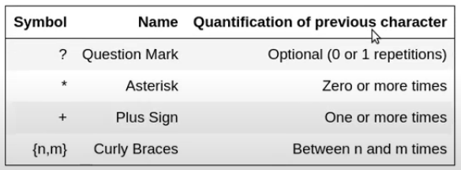

**Curly Bracket Syntax:**

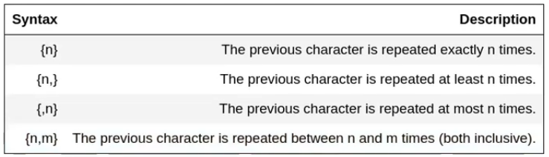

**Functions in Regular Expression**

1. **compile()**

* This function is used to compile a given pattern and create pattern objects in a Regular Expression.

Syntax:

compile(pattern [,flags])

1. **search()**

* The function is used to locate or search for pattern in a given string.

Syntax:

search(pattern, string, [,flags])

1. **match()**

* The function is used to match the pattern at the beginning of a string.

Syntax:

match(pattern, string, [,flags])

**iv. split()**

* The function is used to split a string into list wherever the regular expression matches.

Syntax:

split(pattern, string, [,maxsplit = 0]

**v. findall()**

* The function is used to find all the substrings where the regular expression matches. It returns the output as list.

Syntax:

findall(pattern, string)

**vi. sub()**

* The function is used to find all the substrings where the regular expression matches and replace them with a different string.

Syntax:

sub(pat,repl,string[,count =0])